US CITIZEN TRAVEL TO EUROPE VS CARIBBEAN IN THE SUMMER MONTHS 2009-2016
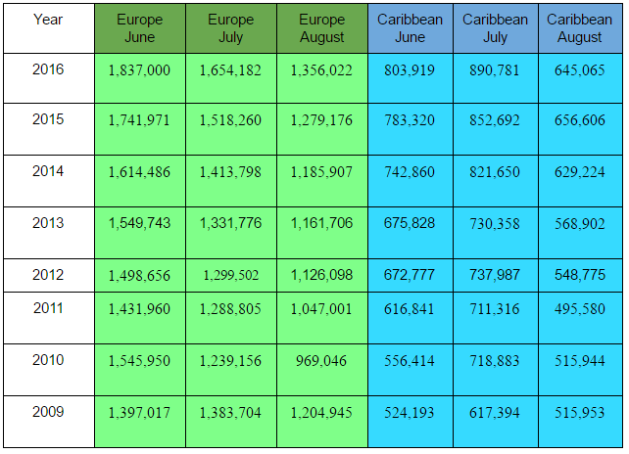
U.S. Department of Commerce, International Trade Administration, and National Travel and
Tourism Office (NTTO). (2016). Monthly Tourism Statistics - U.S. Travelers Overseas.
Retrieved March 23, 2017, from http://travel.trade.gov/research/monthly/departures/

2. One-Variable Statistics for Europe:
The mean number of US citizens that traveled to Europe in the summer months between 2009 and 2016 is approximately 1,378,161 people. The sample standard deviation is 215,845 people. The minimum amount of people who visited Europe during this time is 969,046 people, and the maximum amount of people who have visited Europe was 1,837,000 people. The median number of visitors was 1,369,863. The quartile one value was 1,222,050 people and quartile three value was 1,532,105 people.
Since the median value is lower than the mean value, we can see that the data is positively skewed. From the quartile values, we can see that 50% of the data lies between 1,222,050 people and 1,532,105. Based on the minimum and maximum value, the range of the data is 867,954.

One-Variable Statistics for the Caribbean:
The mean number of US citizens that traveled to the Caribbean in the summer months between 2009 and 2016 is approximately 668,052 people. The sample standard deviation is 113,929 people. The minimum amount of people who visited during this time was 495,580 people, and the maximum amount of people who have visited was 890,781 people. The median number of visitors was 664,691. The quartile one value was 562,658 people and quartile three value was 740,424 people.
Since the median value is slightly lower than the mean value, we can again see that the data is somewhat positively skewed. From the quartile values, we can see that 50% of the data lies between 562,658 people and 740,424. Based on the minimum and maximum value, the range of the data is 395,201.
Comparison of Europe and the Caribbean

From the one-variable we can see that the average number of visitors in the summer months between 2009-2016 is much greater in Europe than in the Caribbean. From the standard deviations, we can see that the data for Europe has more variation than the data for the Caribbean. Another observation is the minimum number of travelers to Europe during that time was higher than the maximum number of visitors to the Caribbean. Due to the relationship between the mean and median, both sets of data are somewhat positively skewed.
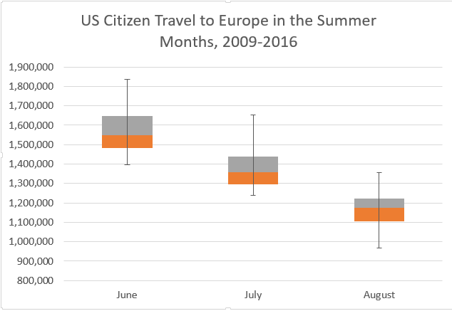
3.

This graph shows three box and whisker plots of the data for Europe. We analyzed the data for each month separately and compared them. From the plots, we can see that median number of visitors in June is greater than the median number in July and August. The minimum number of visitors in June is greater than the maximum number of visitors in August. This shows that there were more visitors in June than August in every year between 2009-2016. In June and July, the box blot shows that the data is positively skewed when comparing the quartiles to the median. The August data is negatively skewed.
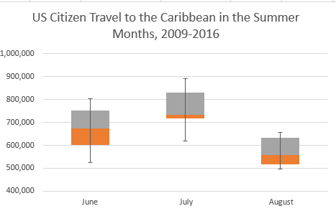

As with the data for Europe, we created box and whisker plots for the three months for the Caribbean data. This showed that the median number of US visitors to the Caribbean in July is high than the median number of visitors in June or August. When comparing the quartiles to the median, it is seen that the data for July is very positively skewed. The data for August is also positively skewed, but not as much as the July data. The data for June seems nearly symmetric. The range of the number of people to visit in August appears smaller than for June and July.

US Citizen Travel to Europe VS US Citizen Travel to the Caribbean in the Summer Months, 2009-2016
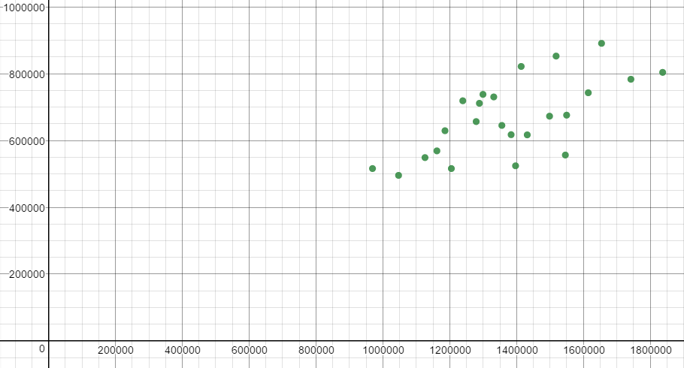
4.
Number of US Citizens Traveled to the Caribbean
Number of US Citizens Traveled to Europe

For this scatter plot, we compared the corresponding months and years in each set of data. The correlation coefficient is .67. This means that there is a moderate positive correlation between US citizen travel to Europe and US citizen travel to the Caribbean in the summer months from 2009-2016.

5. The regression equation for the scatter plot above is $\hat{y}=.354x+180350$. Using this regression equation, I can predict that if 2,000,000 US citizens travel to Europe in a summer month, approximately 888,350 US citizens will travel to the Caribbean in the same month.
$$\hat{y}=.354(2,000,000)+180350$$
$$\hat{y}=888,350$$
6. Europe:
Minimum Value: 969,046 Z-score: $\frac{969,046-1,378161}{215,845}$ = -1.90
This value would be not be considered unusual due to the fact that its z-score is greater than -2 and less than 2. With that being said, the z-score is within one-tenth of being considered unusual and may be worth looking into further.
Europe:
Maximum Value: 1,837,000 Z-score: $\frac{1,837,000-1,378161}{215,845}$ =2.13
This value would be considered unusual due to the fact that its z-score is greater 2.
Caribbean:
Minimum Value: 495,580 Z-score: $\frac{495,580-668053}{113929}$ = -1.51
This value would be not be considered unusual due to the fact that its z-score is greater than -2 and less than 2.
Caribbean:
Maximum Value: 890,781 Z-score:$\frac{890,781-668053}{113929}$ = 1.95
This value would be not be considered unusual due to the fact that its z-score is greater than -2 and less than 2. With that being said, the z-score is within five-hundredths of being considered unusual and may be worth looking into further.

7. Europe:
95% Confidence Interval- $1,291,805≤μ≤1,464,517$
We are 95% confident that the true mean number of US citizens that travel to Europe during the summer months is between 1,291,805 people and 1,464,517people.
$$E=\left(1.96\right)\frac{215845}{\sqrt{24}}= 86,356$$
$$1,378,161-86,356≤μ≤1,378,161+86,356$$
$$1,291,805≤μ≤1,464,517$$

99% Confidence Interval- $1,264,665≤μ≤1,491,657$
We are 99% confident that the true mean number of US citizens that travel to Europe during the summer months is between $1,264,665$ people and $1,491,657$ people.
$$E=\left(2.576\right)\frac{215845}{\sqrt{24}}= 113,496$$
$$1,378,161-113,496≤μ≤1,378,161+113,496$$
$$1,264,665≤μ≤1,491,657$$

Caribbean:
95% Confidence Interval- $622,472≤μ≤713,634$
We are 95% confident that the true mean number of US citizens that travel to the Caribbean during the summer months is between $622,472$ people and $713,634$ people.
$$E=\left(1.96\right)\frac{113929}{\sqrt{24}}= 45,581$$
$$668,053-45,581≤μ≤668,053+45,581$$
$$622,472≤μ≤713,634$$

99% Confidence Interval- $608,146≤μ≤727,960$
We are 99% confident that the true mean number of US citizens that travel to the Caribbean during the summer months is between $608,146$ people and $727,960$ people.
$$E=\left(2.576\right)\frac{113929}{\sqrt{24}}= 59,907$$
$$668,053-59,907≤μ≤668,053+59,907$$
$$608,146≤μ≤727,960$$

If the confidence intervals for the two different data sets overlap, there is a chance that the two population means may be equal. If they do not overlap, we are 95% or 99% (or whatever percent our confidence interval is) sure that the population means for the two sets of data are different.
For our data, neither the 95% confidence intervals nor the 99% confidence intervals overlap. Therefore, we can say with some confidence that the true mean of US citizens to travel to Europe in the summer months and the true mean of US citizens to travel to the Caribbean in the summer months are different.

